Wicomb, Zoë (1948—)

Novelist, short story writer, and essayist Zoe Wicomb was born in Namaqualand, South Africa. Much of her fiction and criticism deals with the construction of racial identity in South Africa; under the Apartheid system, Wicomb and her family were considered ‘coloured,’ the label applied to, among others, persons of mixed racial background. Her first collection of linked short stories, You Can’t Get Lost in Cape Town (1987), follows a young mixed-race woman as she leaves Namaqualand for an education in Cape Town and abroad, developing a political and writerly identity in response to the pressures of Apartheid’s racialized political climate. The novel David’s Story (2000) moves to the reconstruction era, interweaving the 1991 memoirs of David Dirkse, a fictional member of the armed wing of the African National Congress, with an account of the cross-country treks of the Griqua people under the leadership of Andrew Le Fleur in the nineteenth century. Playing in the Light (2006) examines the legacy of Apartheid hierarchies, as a ‘white’ South African discovers in the late 1990s that her parents had been categorized as ‘coloured’ under the regime. The One that Got Away (2008) is a series of stories set in Glasgow and South Africa and linked by a group of often tangentially related characters.

Although her fiction draws on elements of her own life, Wicomb thwarts easy parallels by emphasizing the literary artifice involved in all writing. In You Can’t Get Lost in Cape Town, for instance, protagonist and narrator Frieda Shenton initially indicates that her mother died young, an assertion contradicted by the later reappearance of her mother, who criticizes Frieda’s fictional reworkings of the family’s past. With its emphasis on autobiography as an act of selective narration, David’s Story similarly undermines the reliability of storytelling of all kinds. These acts of fictive self-narration mirror processes of national and racial construction Wicomb identifies in both Apartheid and post-Apartheid South Africa.

References and Further Reading
Works by Wicomb:
Novels and Short Story Collections
You Can’t Get Lost in Cape Town (1987)
David’s Story (2000)
Playing in the Light (2006)
The One that Got Away (2008)

Essays (selected)
“To Hear the Variety of Discourses.” Current Writing 2 (1990): 35-44.
“An Author’s Agenda.” Critical Fictions: The Politics of Imaginative Writing, ed. Philomena Mariani. Seattle: Bay Press, 1991.
“Nation, Race and Ethnicity: Beyond the Legacy of Victims.” Current Writing 4.1 (1992): 15-20.
“Culture Beyond Color?” Transition 60 (1993): 27-32.
“Comment on Return to South Africa.” Kunapipi 16.1 (1994): 575-576.
“Shame and Identity: The Case of the Coloured in South Africa.” Writing South Africa: Literature, Apartheid, and Democracy, 1970-1995, ed. Derek Attridge and Rosemary Jolly. Cambridge: Cambridge University Press, 1998.
“Translations in the Yard of Africa.” Journal of Literary Studies 18:3-4 (2002): 209-223.

Critical Sources:
Attridge, Derek. “Zoë Wicomb’s Home Truths.” Journal of Postcolonial Writing, 41:2 (2005): 156-165.
Marais, Mike. “Bastards and Bodies in Zoë Wicomb’s David’s Story.” The Journal of Commonwealth Literature 40.3 (2005): 21-36.
Marais, Sue. “Getting Lost in Cape Town: Spatial and Temporal Dislocation in the South African Short Fiction Cycle”. English in Africa, 22(2): 29-43.
Raiskin, Judith. ““Miskien of Gold Gemake”: Zoë Wicomb.” Snow on the Cane Fields: Women’s Writing and Creole Subjectivity. Minneapolis: U of Minnesota Press, 1996.

Multimedia Resources:
Wicomb reads at the Dundee Literary Salon, Dundee University, 2008: http://vimeo.com/5230553

Photo:
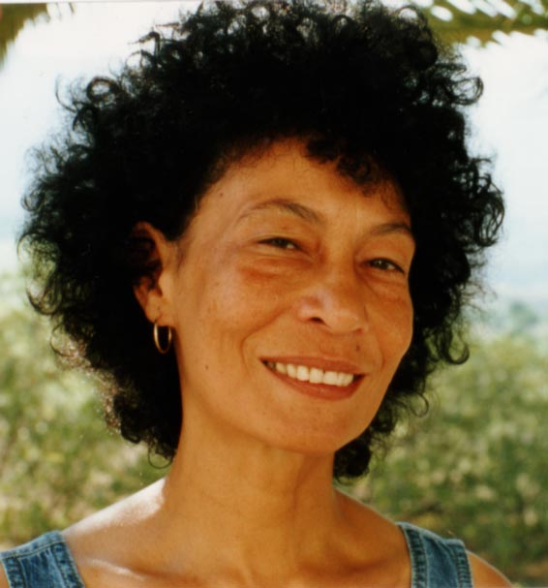
Image source: Scottish Book Trust [http://www.scottishbooktrust.com/contacts/zoe-wicomb]. Copyright status uncertain, although this image is very commonly reproduced in articles and web pages about Wicomb.

